# Tables and figures

**Table 1.** Summary of the **UAW-GM Cohort** restricted to men employed in or after 1970.

|  |  |  |  |  |  |
| --- | --- | --- | --- | --- | --- |
|  | All records | |  | Complete records | |
| $N$ (person $⋅$ years) | $$26 890$$ | $$(933 187)$$ |  | $$19 663$$ | $$(650 685)$$ |
| **Race**, $n$ (%) |  |  |  |  |  |
| White | $$19 388$$ | $$(72\%)$$ |  | $$13 293$$ | $$(68\%)$$ |
| Black | $$5 262$$ | $$(20\%)$$ |  | $$4 142$$ | $$(21\%)$$ |
| Unknown | $$2 240$$ | $$(8\%)$$ |  | $$2 228$$ | $$(11\%)$$ |
| **Plant ${​ }^{a}$**, $n$ (%) |  |  |  |  |  |
| Plant 1 | $$6 935$$ | $$(26\%)$$ |  | $$6 627$$ | $$(34\%)$$ |
| Plant 2 | $$10 351$$ | $$(38\%)$$ |  | $$6 412$$ | $$(33\%)$$ |
| Plant 3 | $$9 604$$ | $$(36\%)$$ |  | $$6 624$$ | $$(34\%)$$ |
| **Complete work records** | $$19 663$$ | $$(73\%)$$ |  | $$19 663$$ | $$(100\%)$$ |
| **Year of hire** | $$1967$$ | $$(1956, 1975)$$ |  | $$1965$$ | $$(1953, 1971)$$ |
| **Age at hire** | $$24$$ | $$(20, 31)$$ |  | $$25$$ | $$(20, 33)$$ |
| **Year of birth** | $$1942$$ | $$(1927, 1950)$$ |  | $$1936$$ | $$(1923, 1947)$$ |
| **Year of worker exit** | $$1991$$ | $$(1982, 1995)$$ |  | $$1987$$ | $$(1979, 1993)$$ |
| **Age at worker exit** | $$49$$ | $$(40, 58)$$ |  | $$52$$ | $$(39, 61)$$ |
| **Age at death among deceased** | $$70$$ | $$(60, 79)$$ |  | $$71$$ | $$(61, 80)$$ |
| **Year of death among deceased** | $$1999$$ | $$(1989, 2008)$$ |  | $$1997$$ | $$(1988, 2007)$$ |
| **Suicide cases** | 203 |  |  | 179 |  |
| **Fatal overdose cases** | 55 |  |  | 34 |  |
| Statistics shown are median (first quartile, third quartile), unless otherwise indicated. ${​ }^{a}$ Some subjects worked at several sites; plant indicates the site of longest work record time. | | | | | | |

**Figure 1.** Crude rate (per 10,000 person-years) of suicide by calendar year in the **UAW-GM Cohort** restricted to men employed in or after 1970.

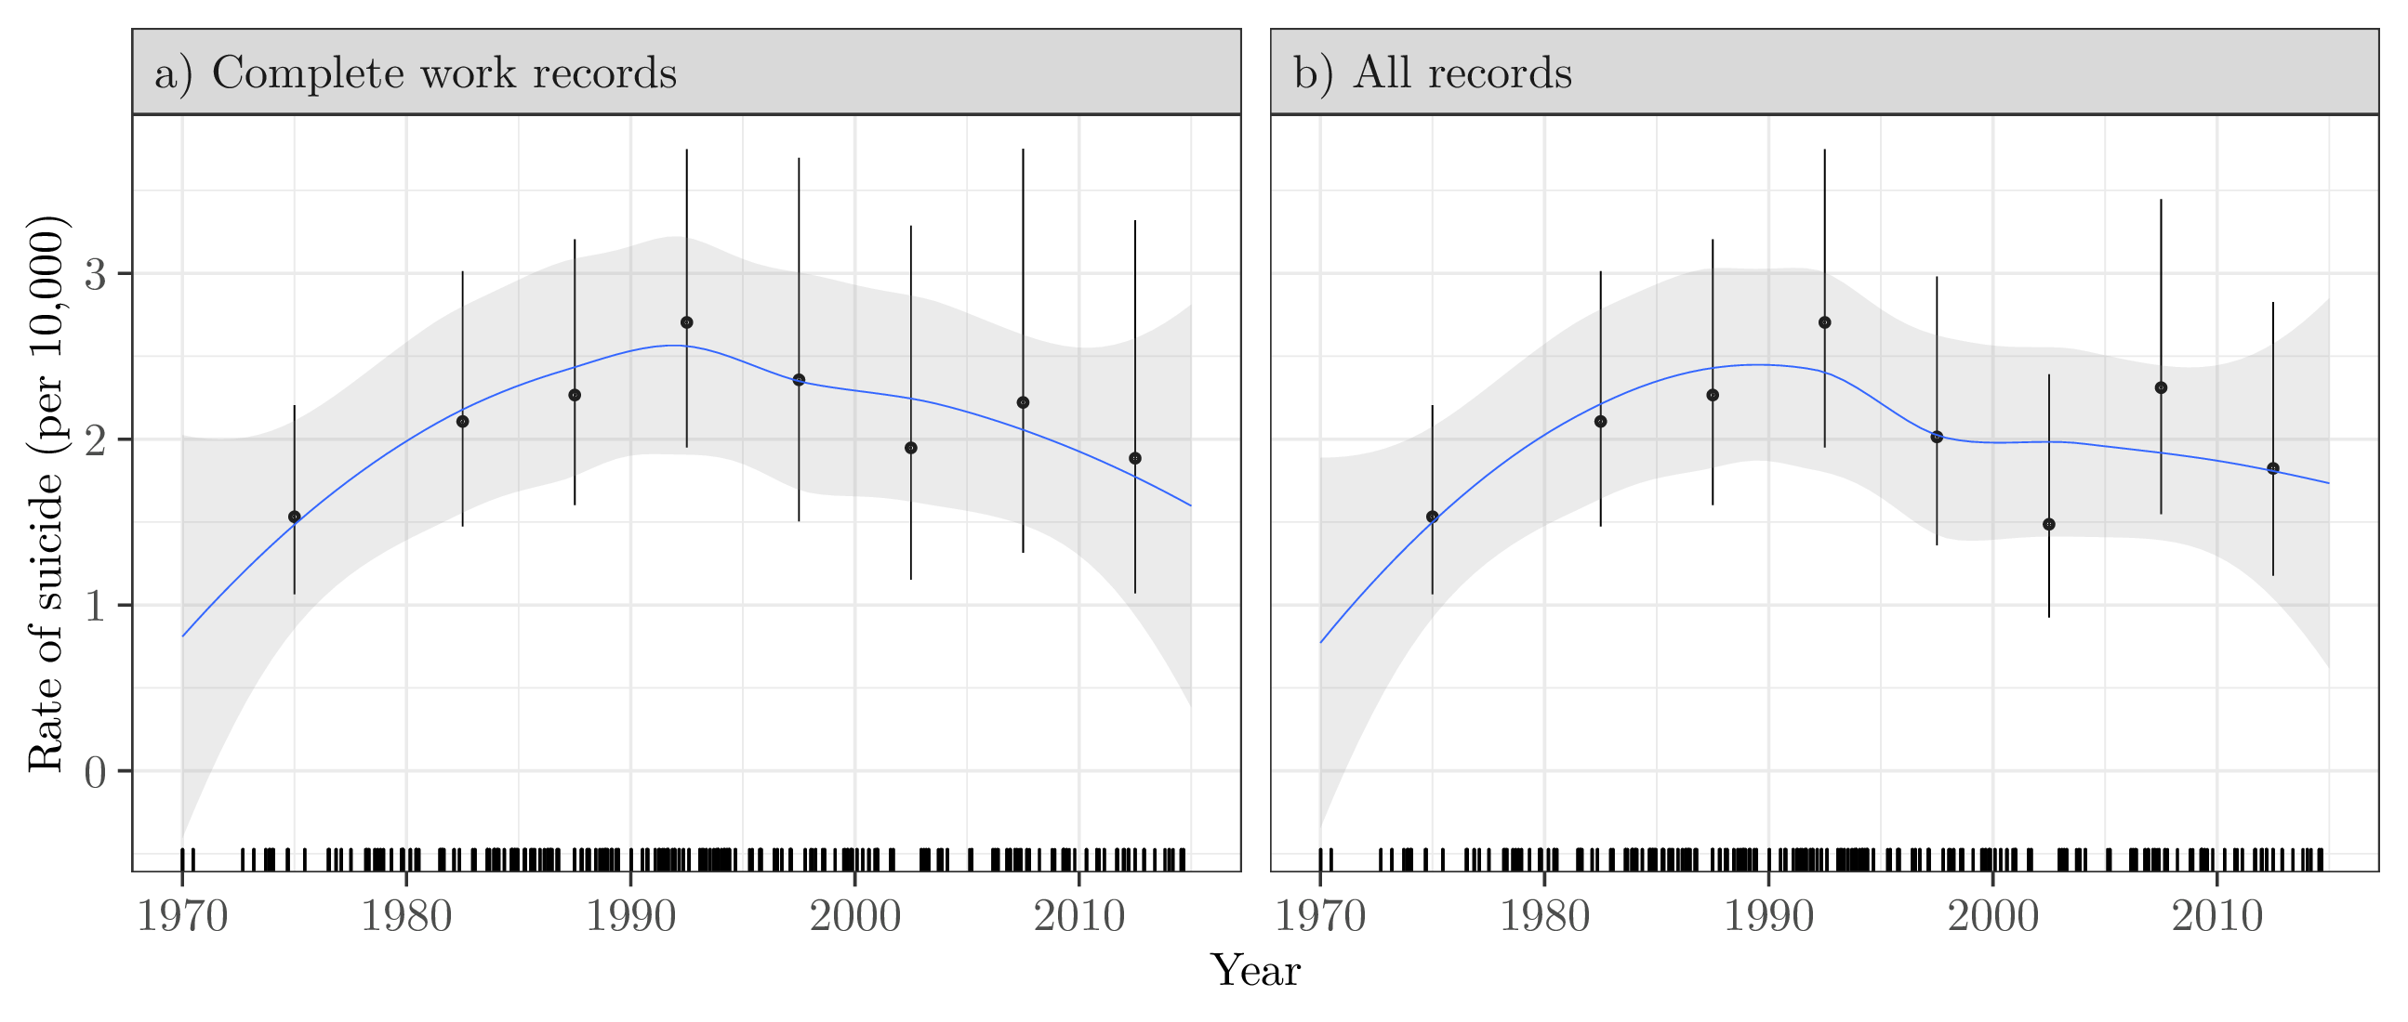

**Table 2.** Adjusted hazard ratio estimates for **suicide** by employment status in the **UAW-GM Cohort** restricted to men employed in or after 1970.

|  |  |  |  |  |  |  |  |  |  |
| --- | --- | --- | --- | --- | --- | --- | --- | --- | --- |
|  |  | Recorded worker exit date | | |  | Fuzzy worker exit date ${​ }^{a}$ | | | |
| Job exit status |  | $$n$$ | HR | (95% CI) |  | $$n$$ | HR | (95% CI) | |
| At work |  | $$21$$ | $$1.0$$ | – |  | $$27$$ | $$1.0$$ | – | |
| Not at work |  | $$158$$ | $$17.7$$ | $$\left(10.8, 29.1\right)$$ |  | $$152$$ | $$12.5$$ | $$(7.9, 19.7)$$ | |
| Estimates were adjusted for plant, race, year of hire, and calendar year. Risk sets were indexed by age. Women were excluded from this analysis. ${​ }^{a}$ Cases that occurred within a week after the recorded worker exit date were assumed to have occurred while still employed. | | | | | | | | |

**Table 3.** Adjusted hazard ratio estimates for **suicide** and the combined outcome of **suicide and fatal overdose** in the **UAW-GM Cohort** restricted to men employed in or after 1970.

|  |  |  |  |  |  |  |  |  |
| --- | --- | --- | --- | --- | --- | --- | --- | --- |
|  |  | Suicide | | |  | Suicide and fatal overdose | | |
| Age at worker exit |  | $$n$$ | HR | (95% CI) |  | $$n$$ | HR | (95% CI) |
| $55$ or older |  | $$42$$ | $$1.0$$ | – |  | $$45$$ | $$1.0$$ | – |
| $40$ to $54$ |  | $$48$$ | $$1.2$$ | $$(0.8, 1.8)$$ |  | $$51$$ | $$1.2$$ | $$(0.8, 1.8)$$ |
| $30$ to $39$ |  | $$41$$ | $$1.7$$ | $$(1.1, 2.6)$$ |  | $$56$$ | $$2.1$$ | $$(1.4, 3.1)$$ |
| $19$ to $29$ |  | $$27$$ | $$1.4$$ | $$(0.8, 2.3)$$ |  | $$38$$ | $$2.0$$ | $$(1.2, 3.1)$$ |
| Estimates were adjusted for race, plant, and calendar year of worker exit. Risk sets were indexed by time since worker exit. Women and those with unknown date of worker exit were excluded from this analysis. | | | | | | | | |

**Figure 2.** Crude rate (per 10,000 person-years) of the combined outcome of suicide and fatal overdose by calendar year in the **UAW-GM Cohort** restricted to men employed in or after 1970.

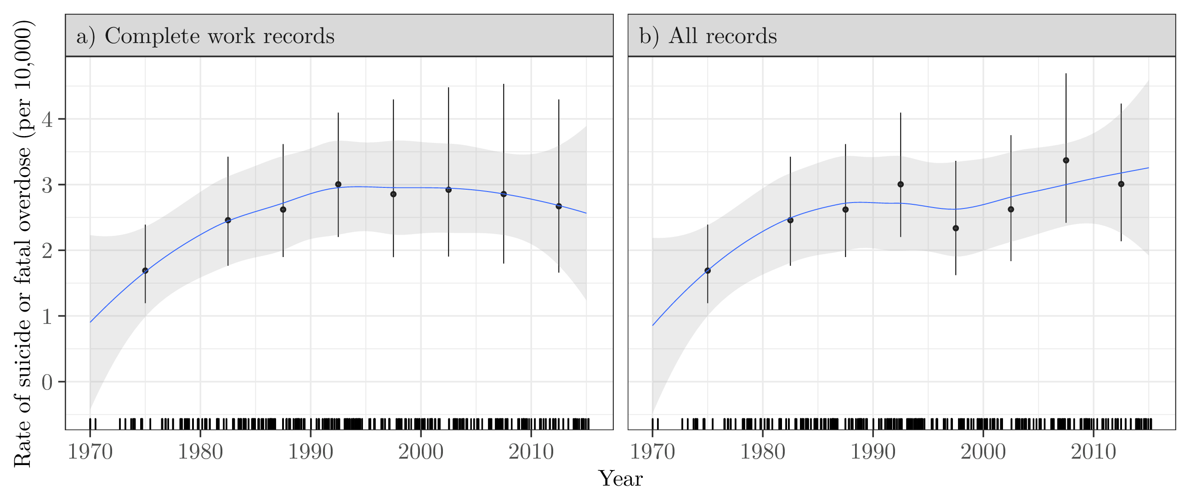

# Additional Online Materials

**eFigure 1.** Directed acyclic graph representing our working causal assumptions.

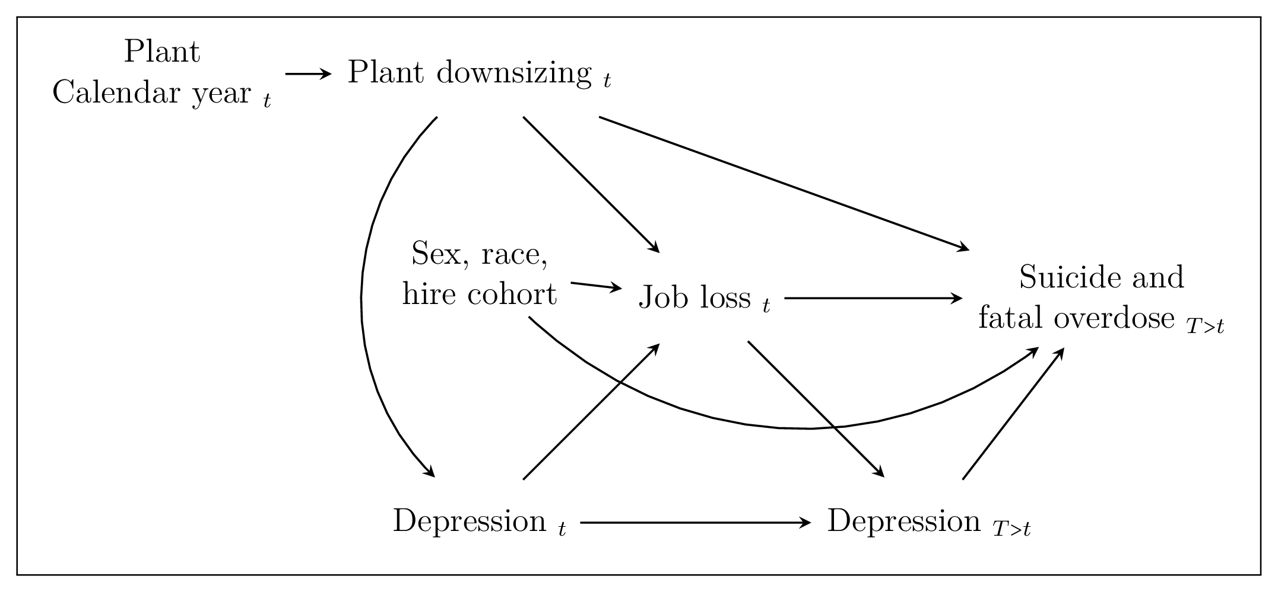

**eFigure 2.** Histograms of age at death among suicide and fatal overdose cases in the **UAW-GM Cohort** restricted to men employed in or after 1970.

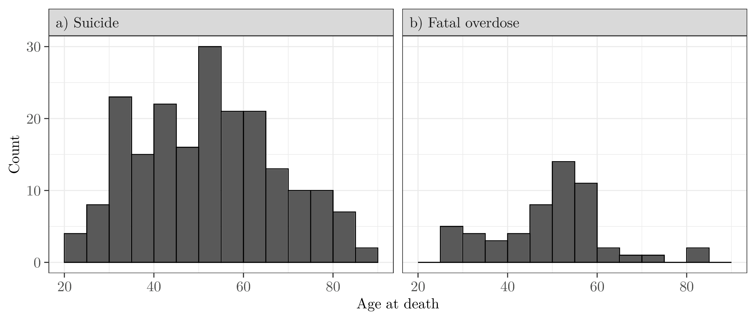

**eFigure 3.** Histograms of time between worker exit date and date of suicide in the **UAW-GM Cohort** restricted to men employed in or after 1970. Bins corresponding to cases that occurred while employed are indicated in purple.

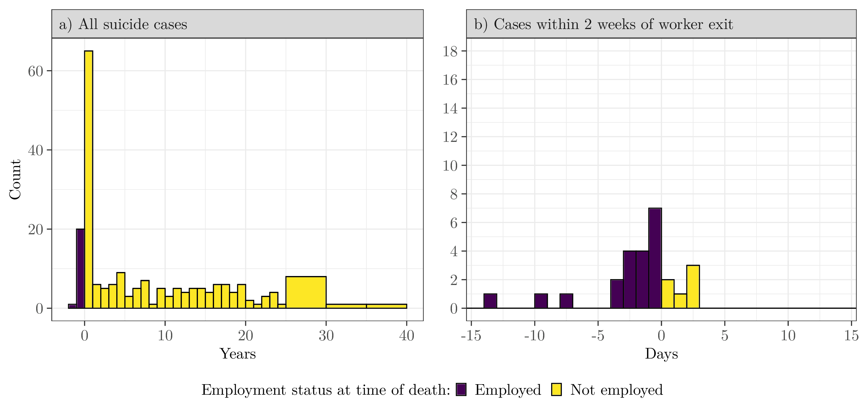

**eTable 1.** Adjusted hazard ratio estimates for **suicide** and the combined outcome of **suicide and fatal overdose** in the **UAW-GM Cohort**, within **five** years of worker exit, restricted to men employed in or after 1970 who left work by December 31, 1994.

|  |  |  |  |  |  |  |  |  |
| --- | --- | --- | --- | --- | --- | --- | --- | --- |
|  |  | Suicide | | |  | Suicide and fatal overdose | | |
| Age at worker exit |  | $$n$$ | HR | (95% CI) |  | $$n$$ | HR | (95% CI) |
| $55$ or older |  | $$28$$ | $$1.0$$ | – |  | $$30$$ | $$1.0$$ | – |
| $40$ to $54$ |  | $$28$$ | $$1.3$$ | $$(0.8, 2.3)$$ |  | $$29$$ | $$1.3$$ | $$(0.8, 2.3)$$ |
| $30$ to $39$ |  | $$21$$ | $$1.7$$ | $$(1.0, 3.0)$$ |  | $$26$$ | $$2.0$$ | $$(1.2, 3.4)$$ |
| $19$ to $29$ |  | $$9$$ | $$1.2$$ | $$(0.5, 2.6)$$ |  | $$13$$ | $$1.7$$ | $$(0.8, 3.4)$$ |
| Estimates were adjusted for race, plant, and worker exit date. Risk sets were indexed by time since worker exit. Women and those with unknown date of worker exit were excluded from this analysis. | | | | | | | | |

**eFigure 4.** Continuous adjusted hazard ratio estimates for **suicide** and the combined outcome of **suicide and fatal overdose** in the **UAW-GM Cohort** restricted to men employed in or after 1970.

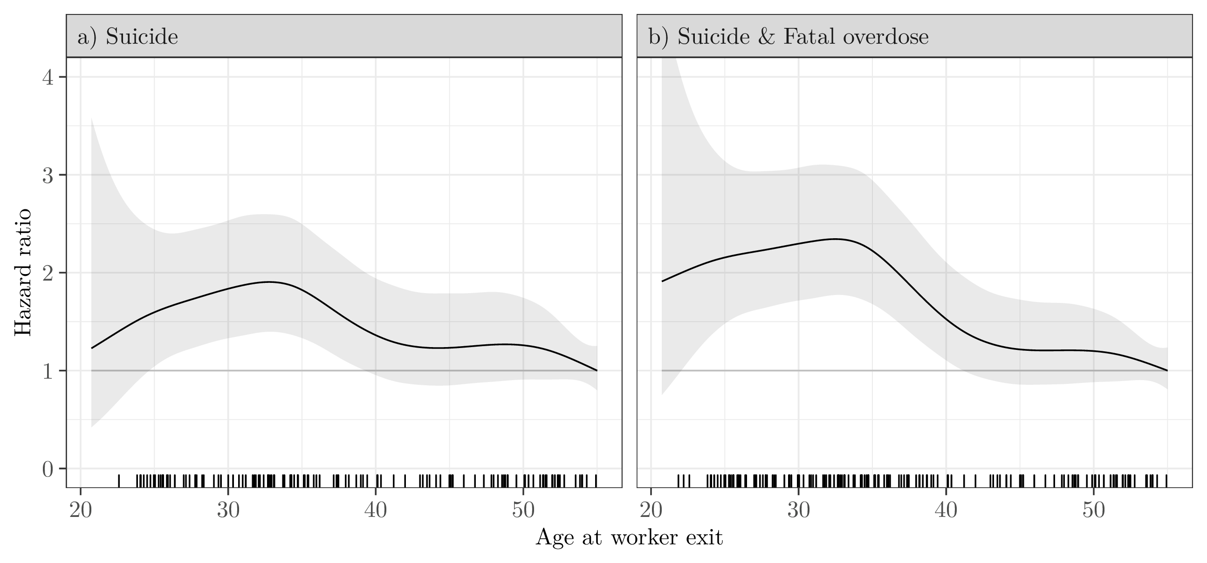

**eTable 2.** Adjusted subdistribtuion hazard ratio estimates for **suicide** and the combined outcome of **suicide and fatal overdose** in the **UAW-GM Cohort**, restricted to men employed in or after 1970.

|  |  |  |  |  |  |  |  |  |
| --- | --- | --- | --- | --- | --- | --- | --- | --- |
|  |  | Suicide | | |  | Suicide and fatal overdose | | |
| Age at worker exit |  | $$n$$ | sdHR | (95% CI) |  | $$n$$ | sdHR | (95% CI) |
| or older |  |  |  | – |  |  |  | – |
| to |  |  |  |  |  |  |  |  |
| to |  |  |  |  |  |  |  |  |
| to |  |  |  |  |  |  |  |  |
| Estimates were adjusted for race, plant, and worker exit date. Risk sets were indexed by time since worker exit. Women and those with unknown date of worker exit were excluded from this analysis. | | | | | | | | |

**eTable 3.** Adjusted subdistribtuion hazard ratio estimates for **suicide** and the combined outcome of **suicide and fatal overdose** in the **UAW-GM Cohort**, within **five** years of worker exit, restricted to men employed in or after 1970.

|  |  |  |  |  |  |  |  |  |
| --- | --- | --- | --- | --- | --- | --- | --- | --- |
|  |  | Suicide | | |  | Suicide and fatal overdose | | |
| Age at worker exit |  | $$n$$ | sdHR | (95% CI) |  | $$n$$ | sdHR | (95% CI) |
| or older |  |  |  | – |  |  |  | – |
| to |  |  |  |  |  |  |  |  |
| to |  |  |  |  |  |  |  |  |
| to |  |  |  |  |  |  |  |  |
| Estimates were adjusted for race, plant, and worker exit date. Risk sets were indexed by time since worker exit. Women and those with unknown date of worker exit were excluded from this analysis. | | | | | | | | |

**eFigure 5a.** Follow-up diagram for **suicide** cases in the **UAW-GM Cohort** restricted to men employed in or after 1970, ordered by employment worker exit date.

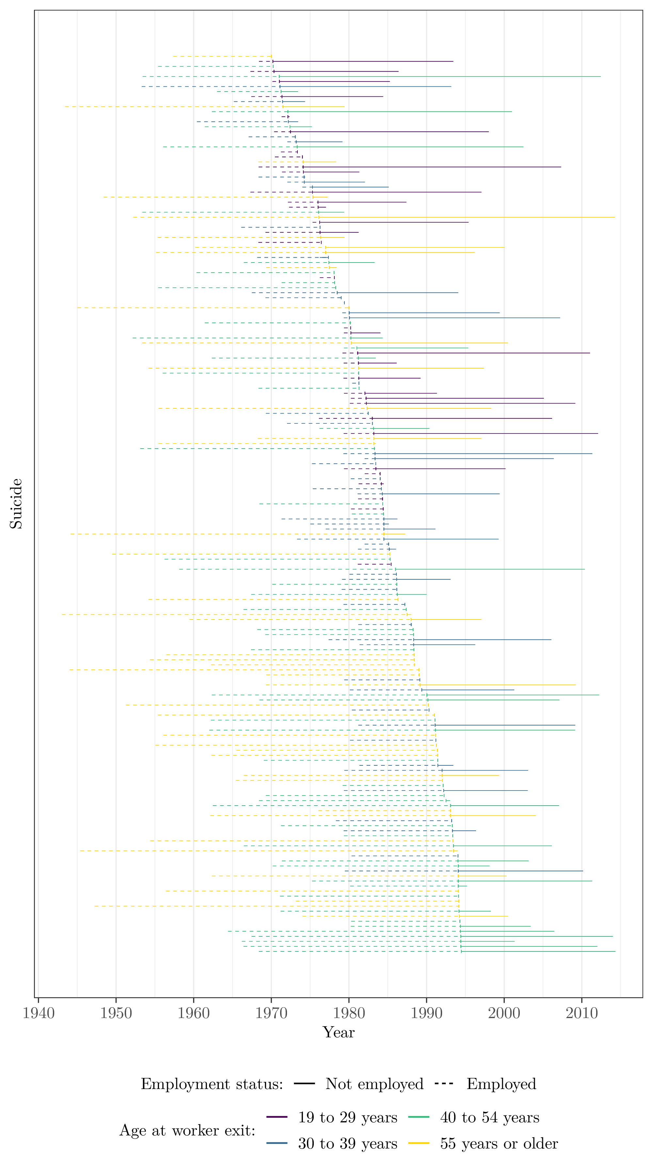

**eFigure 5b.** Follow-up diagram for **fatal overdose** cases in the **UAW-GM Cohort** restricted to men employed in or after 1970, ordered by employment worker exit date.

